|  |  |
| --- | --- |
|  | **FPT ACADEMY INTERNATIONAL**  **FPT – APTECH COMPUTER EDUCATION** |

**Centre Name: ACE-HCMC-2-FPT.**

**Address: 590 Cach Mang Thang 8, District 3, Ho Chi Minh City, Viet Nam.**

**ABCD Mall Online**

|  |  |  |
| --- | --- | --- |
| **Supervisor.** | Nguyen Ngo Phuoc | |
| **Batch.** | T1.1910.M1 | |
| **Group.** | 3 | |
| **Serial No.** | **Enrollment Number** | **Student Name** |
| 1. | Student1235025 | Nguyen Nhuan Phat |
| 2. | Student1233877 | Dao Nguyen Xuan Huy |
| 3. | Student1235028 | Hoang Giang Chuan |
| 4. | Student1233862 | Vo Duc Chinh |

Month March Year 2021

This is a certification proving that

**Mr. Nguyen Nhuan Phat**

**Mr. Dao Nguyen Xuan Huy**

**Mr. Hoang Giang Chuan**

**Mr. Vo Duc Chinh**

**Have successfully design and developed:**

**eProject: ABCD Mall Online**

**Submitted by:**

**Mr. Nguyen Ngo Phuoc**

**Date of issue: 18th March 2021**

**Authorized Signature**

Table of Contents

1 Acknowledgement 3

2 eProject Synopsis And analysis 3

2.1 Introduction: 3

2.2 Website designing requirement: 3

2.3 Website functionalities explanation: 3

3 Hardware / Software Requirements 3

3.1 Server Requirement: 3

3.2 Client Requirement: 3

3.3 Software and technologies used for project: 3

4 Architecture & Design of the project: 3

4.1 Presentation Tier: 3

4.2 Business Logic Tier: 3

4.3 Data Access Tier: 3

5 Algorithms - Data Flowchart: 3

5.1 Main data flow for client: 3

5.2 Admin login function: 3

5.3 Admin logout function: 3

5.4 Insert data function: 3

5.5 Update data function: 3

5.6 Delete data function: 3

5.7 Ticket booking function: 3

6 data flow diagram: 3

6.1 Context Diagram: 3

6.2 Level 0 DFD: 3

6.3 Level 1 DFD: 3

6.4 Level 2 DFD: 3

REVIEW 3 3

7 Database Design 3

7.1 Database diagram 3

7.2 Table Design 3

7.2.1 Admin table 3

7.2.2 Feedback table 3

7.2.3 Stores table 3

7.2.4 Plots table 3

7.2.5 Brands table 3

7.2.6 Products table 3

7.2.7 Movies table 3

7.2.8 Cinemas table 3

7.2.9 Seats table 3

7.2.10 Seatreserve table 3

8 User Interface 3

8.1 Admin Views 3

8.2 Store management view 3

8.3 Store details view 3

8.4 Create Store view 3

8.5 Delete Store view **Error! Bookmark not defined.**

8.6 Create product view 3

8.7 Product details view 3

8.8 Create brand view 3

8.9 Brand details view 3

8.10 Movie management view 3

8.11 Seat reservation management view 3

8.12 Movie sales chart view 3

8.13 Feedback management view 3

8.14 Admin account management view 3

8.15 Client Views 3

8.16 Homepage 3

8.17 Stores index view 3

8.18 Store details view 3

8.19 Brands index view 3

8.20 Gallery view 3

8.21 Mall diagram view 3

8.22 Mall contact view 3

8.23 Movies index view 3

8.24 Movie details view 3

8.25 Seat picking view 3

8.26 Ticket information view 3

9 Code integrity 3

9.1 Google chart API implementation 3

9.2 Google translate API implementation 3

9.3 Qrious API implementation 3

9.4 Seat picking process 3

6.4.1 Store Management: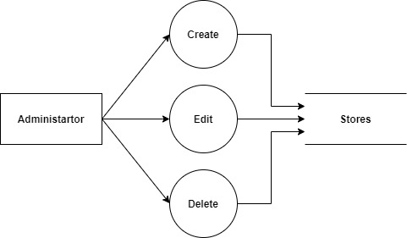 3

6.4.2 Movie Management: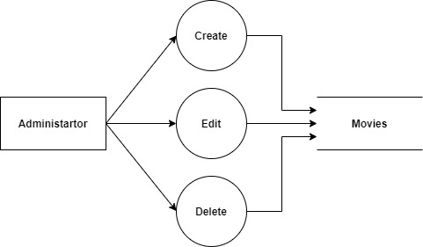 3

6.4.3 Galleries Management: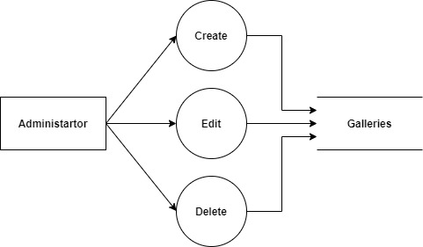 3

6.4.4 Account Management: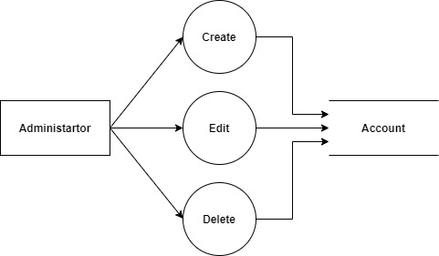 3

6.4.5 Feedback Management: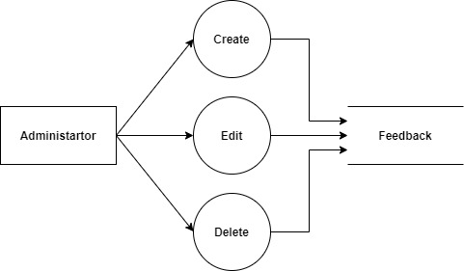 3

6.4.6 Feedback And Ticket Submission: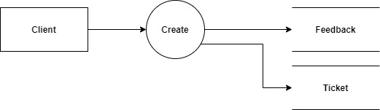 3

6.5 Use Case Diagram: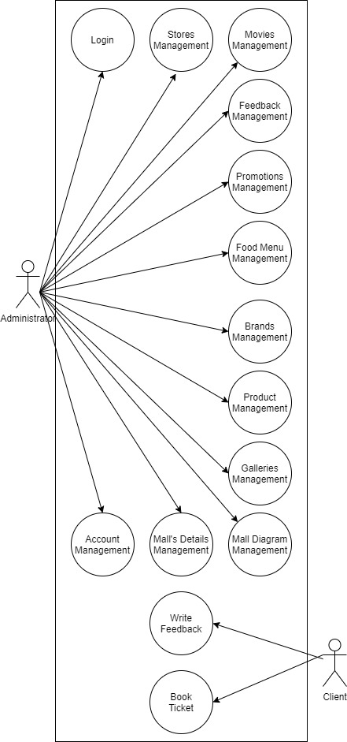 3

6.5.1 Admin Use Case: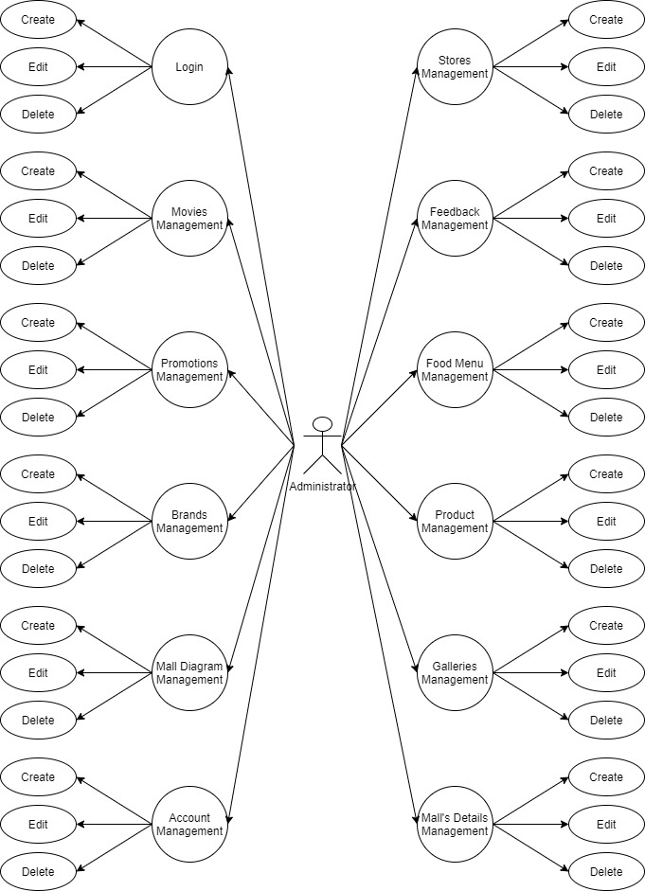 3

6.5.2 Client Use Case: 3

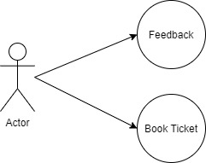 3

6.6 Entitiy-Relationship Design: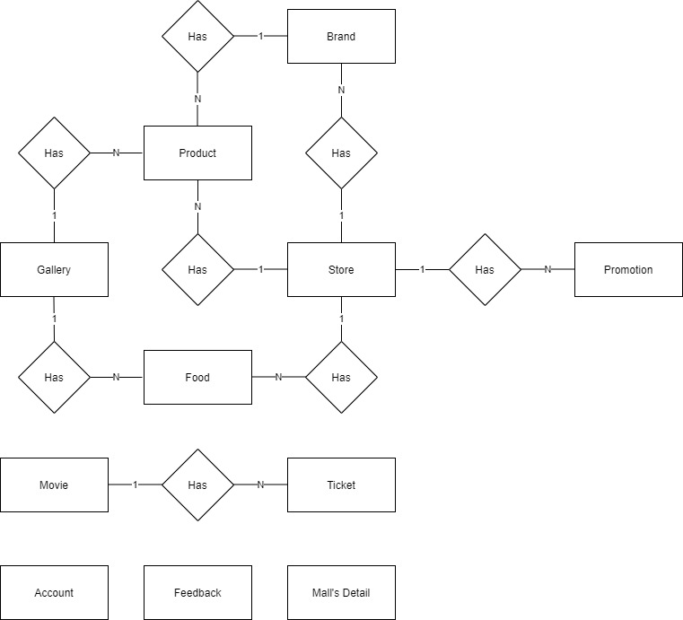 3

6.7 Entities and Properties: 3

6.7.1 Store Entity & Properties: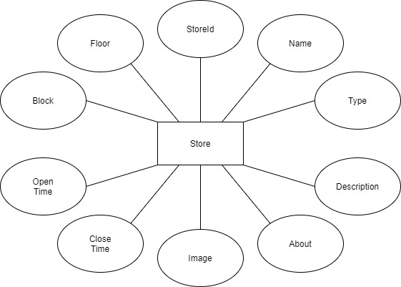 3

6.7.2 Feedback Entity & Properties: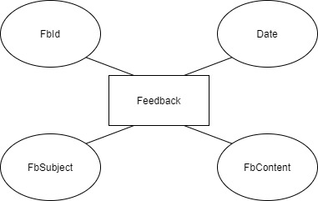 3

6.7.3 Account Entity & Properties: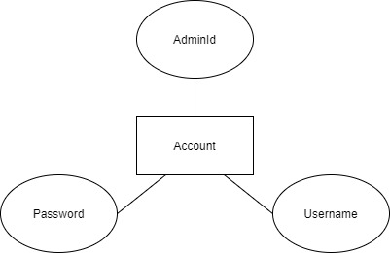 3

6.7.4 Product Entity & Properties: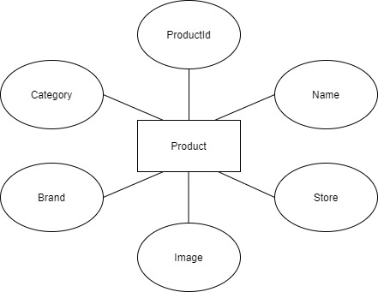 3

6.7.5 Brand Entity & Properties: 3

6.7.6 Movie Entity & Properties: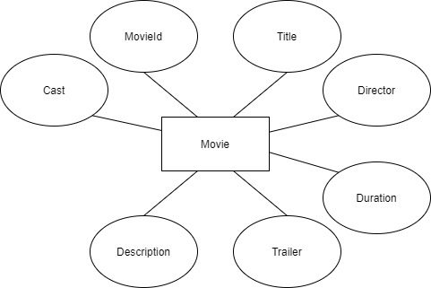 3

6.7.7 Ticket Entity & Properties: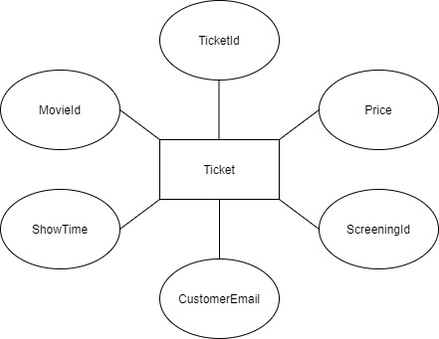 Task Sheet Review 2 3

**REVIEW 1**

# Acknowledgement

We would like to acknowledge all those who have given support and help us make the project a success.

We wish to express our deep gratitude to all teachers who have been devoting their lives to teach us how to stand-alone and walk ahead.

We are grateful to our families who take care and encourage us even though we are successful or failed, also to our friends who are always care of us. They never leave us alone and always look forward to us when we are on any road of the life.

We are much thankful to the entire staff and chairpersons at the Head Office of Aptech Worldwide, Aptech – Vietnam, and FPT – Aptech Center who have been organizing and looking after our studying course.

There are no words to show our appreciation for teachers of FPT Aptech Centre who have been organizing and looking after us during our studying course to finish this project. Our special thanks Mr Tran Phuoc Sinh who works day by day to teach and guide us, e-Project Team at the Head Office who instruct and help us.

Finally, we would like to offer many thanks to all our schoolfellows for their valuable suggestions.

We would like to thank sincerely!

# eProject Synopsis And analysis

## Introduction:

The ABCD mails situated in sub-urban place of Mumbai and was opened by ABCD Developers Pvt Ltd. The 250,000 sq ft (23,000 m2) mall with a frontage of 700 ft (210 m). It was designed by Cooper and their partners. R Mall is a 4-storeyed air-conditioned mall covering an area of approximately 80,000 sq ft (7,000 m2) on each floor. The site includes a 7 level car parking facility.

The owner of the mall wants to develop the website of their mall in order to advertise its construction and features. For these they have approach you to create the website.

## Website designing requirement:

The experts have given the requirements they have expected in the website:

• Home Page:

o In the centre it must display the image of the mall with some relevant information about it.

o The links must be shown for navigating the sites and to explore the features of the mall.

• Features of functionalities:

o There should be a separate module for using the admin features and the client features.

o Admin will have the properties of editing the data of the mall like editing the name of the shop added, removed, deleted. While adding the details some images must be added in the website.

o Admin will also have the feature to edit the details of the movies of the mall

o Client will have the property to view the features and edit the desired section them.

o The mall has an advantage features that allow the customer to book the ticket online for the movie through the website.

o Feedback is taken from the customer

o Gallery section will be uploaded by the admin which consist of the pictures of various products available.

## Website functionalities explanation:

Functionalities are explained module wise:

Admin Module:

* Admin will have to login in the website to edit the features.
* Will have the authority to ADD-EDIT-DELETE the content such as shopping centers (along with the list of few items it possess), counters at food court (can add some of the items).
* Can add the details in the gallery section where the top brands item, or food image is presented
* Can view the feedback received by the client users.
* Will have the authority to ADD-EDIT-DELETE the movies which would be running on the multiplex also number seats available must be added.
* Can view the tickets booked by the clients.

Client Module:

* The client can view the website but will not any login section.
* They can view the data like list of the shopping centers, food courts, galleries, contact us details
* They can provide the feedback
* They can book the ticket online by providing the card details. (note if all the allocated seats are booked then it must not allow to book the tickets.)
* Can search the name of the brands shops available, also in the food courts menu.
* Can view the complete diagram of the mall
* Can view the contact details.

# Hardware / Software Requirements

## Server Requirement:

* Hardware

|  |  |
| --- | --- |
| **Component** | **Requirement** |
| **CPU** | Processor type:  Pentium IV-compatible processor or faster  Processor speed:  Recommended: 2.0 GHz or faster |
| **OS** | Microsoft Windows Server 2012 with IIS |
| **Memory (RAM)** | RAM:  Minimum: 512 MB  Recommended: 2 GB or more |
| **Hard Drive** | Free space:  Minimum: 200 MB  Recommended: 50 GB or more  Maximum: Operating system maximum |

* Software

|  |  |
| --- | --- |
| **Component** | **Requirement** |
| **Microsoft .NET Framework** | Version 4.6 or higher |
| **RDBMS** | Microsoft SQL Server 2017 |

## Client Requirement:

* Hardware

|  |  |
| --- | --- |
| **Component** | **Requirement** |
| **CPU** | Processor type:  Pentium III-compatible processor or faster  Processor speed:  Recommended: 1.0 GHz or faster |
| **OS** | All OS (Window, Linux, Android, Mac OS …) |
| **Memory (RAM)** | RAM:  Minimum: 512 MB  Recommended: 1 GB or more  Maximum: Operating system maximum |
| **Hard Drive** | Free space:  Minimum: 10 MB |

* Software

|  |  |
| --- | --- |
| **Component** | **Requirement** |
| **Web Browser** | Chrome, Opera ... (up to date) |

## Software and technologies used for project:

Visual Studio .Net / ASP

Visual Code

Google Translate API

Google Chart API

Qrious QR API

Sql server

Javascript, CSS

Stripe Payment API

Task Sheet Review I

|  |  |  |  |  |  |
| --- | --- | --- | --- | --- | --- |
| Project Ref. No: 3 | Project Title:  Railway Reservation Manage System | Date of Preparation of Activity Plan | | | |
| No. | Task | Actual Start Date | Actual Days | Team Member Names | Status |
| 01 | Acknowledgment | 21-Jan-2021 | 2 | All Members | Completed |
| 02 | Synopsis and Analysis | All Members | Completed |
| 03 | Customer Requirement | All Members | Completed |
| 04 | Task sheet | All Members | Completed |

|  |  |  |
| --- | --- | --- |
|  | Prepare By: Group 3 | Approved By: Faculty |
| Date: 21-Jan-2021 | Team Leader  Nguyen Nhuan Phat | Mr. Ngo Phuoc Nguyen |

**REVIEW 2**

# Architecture & Design of the project:

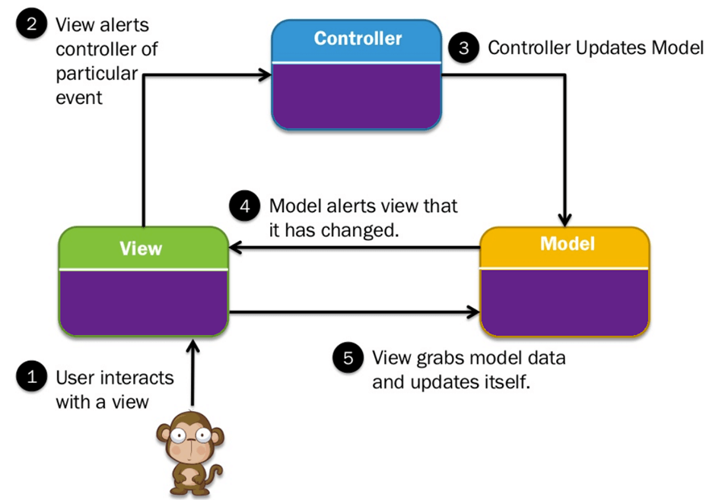

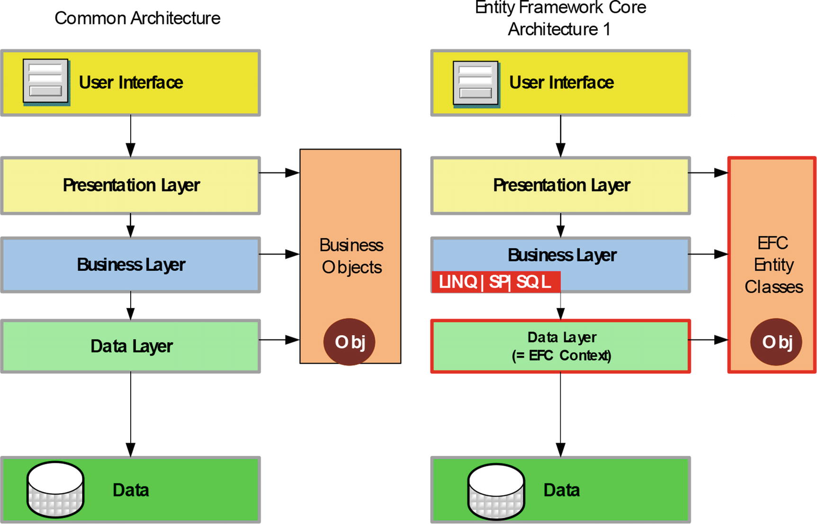

## **Presentation Tier:**

Is the tier in which the users interact with application. Presentation Tier contents Model, View, Controller used to receive a request and response to User.

Technology: ASP.NET MVC5, Razor, HTML, CSS, JavaScript, Ajax, JQUERY, Twitter Bootstrap

## Business Logic Tier:

Is mainly working as the bridge between Data Tier and Presentation Tier. All the Data passes through the Business Tier before passing to the Presentation Tier.

Technology: ASP.NET

## Data Access Tier:

Is basically the server which stores all the application’s data .Data tier contents Database Tables, Database Views and other means of storing Application Data .

Technology: SQL Server, LINQ

# Algorithms - Data Flowchart:

Symbol generates:

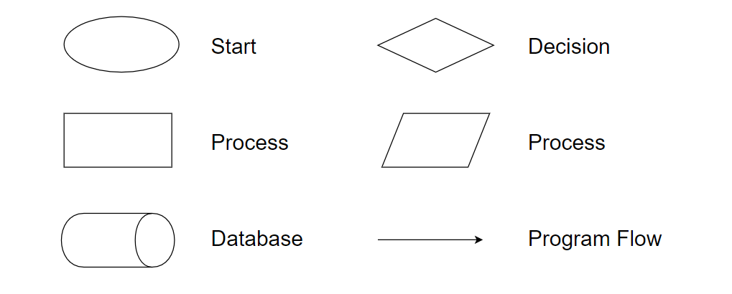

## Main data flow for client:

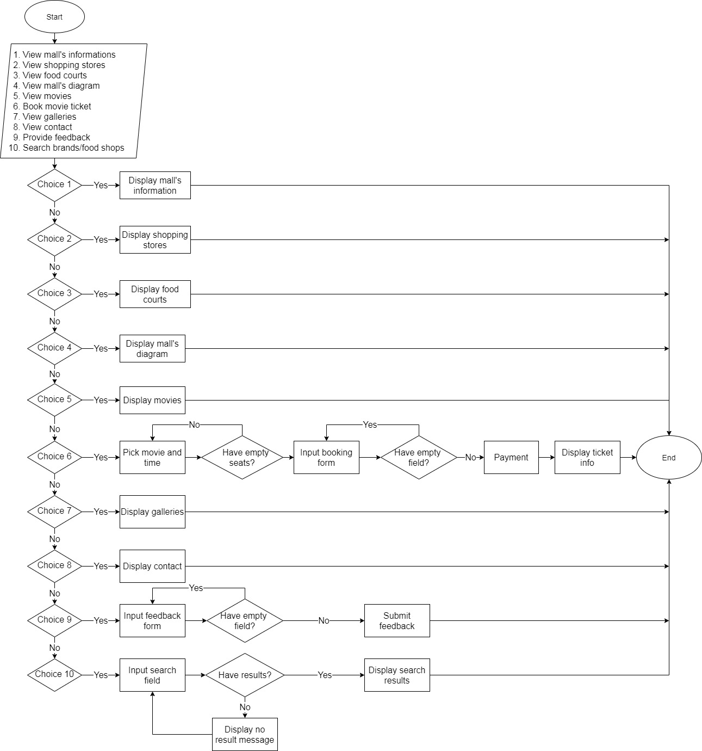

## Admin login function:

## Admin logout function:

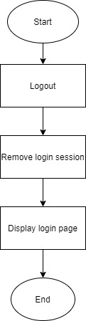

## Insert data function:

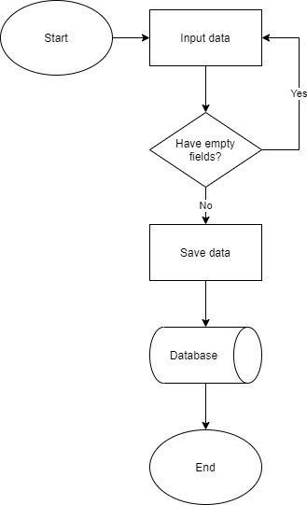

## Update data function:

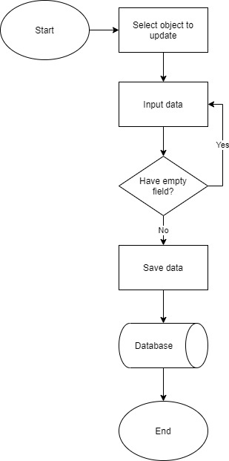

## Delete data function:

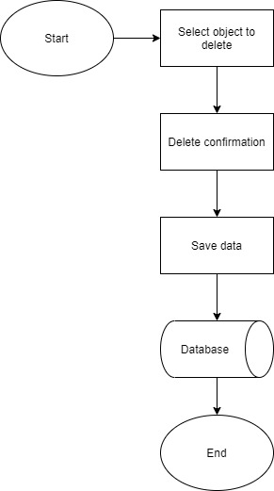

## Ticket booking function:

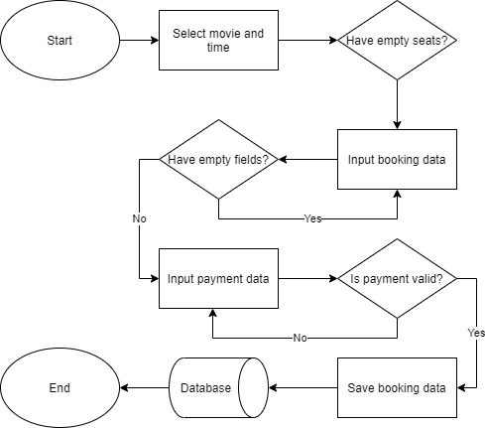

# data flow diagram:

**Define:** Data Flows Diagram (DFD) describes the information flow in the system. The next step of system analysis is to consider in detail the information necessary for the implementation for functions discussed above and the one necessary for the improvement of the functions. Modelling tool frequently used for this purpose is DFD. DFD will support 4 main activities:

**Analysis**: DFD is used to determine requirement of users.

**Design:** DFD is used to map out plan and illustrate solution to analysis and users while designing a new system.

**Communication:** One of the strength of DFD is its simplicity and ease to understand to analysts and users.

**Document:** DFD is used to provide special description of requirement and system design. DFD provide an overview of key functional components of the system but it does not provide any detail on these components. We have to use other tools like database dictionary, process specification to get an idea of which information will be exchanged and how.

**The main components of Context Diagram:**

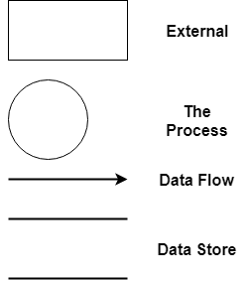

**The external factors:** External factors can be a person, a group of persons or an organization that are sources of information for the systems and are where system products are transferred to.

**The process:** Shows the common function of system

**The data flow:** Describe the movement of information from one part of the system to another.

**The data store:** The Data Store is used to model a collection of data packets at rest. A store is represented graphically by two parallel lines. The name of a Data Store that identifies the store is the plural of the name of the packets that are carried by flows into and out of the Data Store.

## Context Diagram:

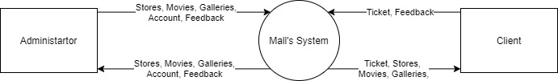

## Level 0 DFD:

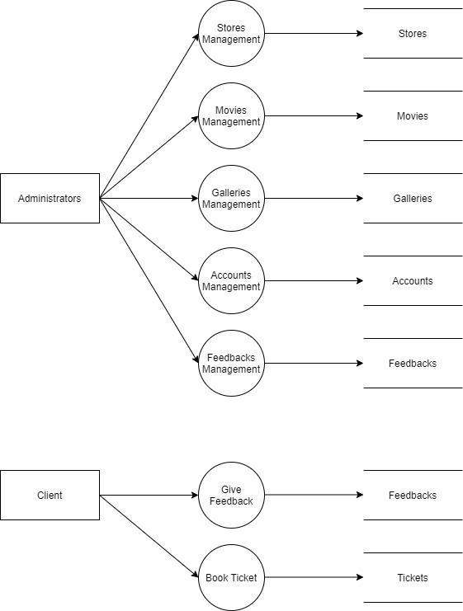

## Level 1 DFD:

## Level 2 DFD:

### Store Management:

### Movie Management:

### Galleries Management:

### Account Management:

### Feedback Management:

### Feedback And Ticket Submission:

## Use Case Diagram:

### Admin Use Case:

### Client Use Case:

## 

## Entitiy-Relationship Design:

## Entities and Properties:

### Store Entity & Properties:

### Feedback Entity & Properties:

### Account Entity & Properties:

### Product Entity & Properties:

### Brand Entity & Properties:

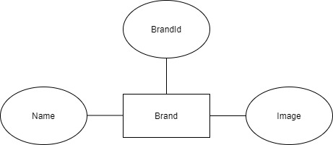

### Movie Entity & Properties:

### Ticket Entity & Properties: Task Sheet Review 2

|  |  |  |  |  |  |
| --- | --- | --- | --- | --- | --- |
| Project Ref. No: 3 | Project Title:  Railway Reservation Manage System | Date of Preparation of Activity Plan | | | |
| No. | Task | Actual Start Date | Actual Days | Team Member Names | Status |
| 01 | Architecture & Design | 31-Jan-2021 | 4 | All Members | Completed |
| 02 | Data Flowchart | All Members | Completed |
| 03 | Data Flow Diagram | All Members | Completed |

|  |  |  |
| --- | --- | --- |
|  | Prepare By: Group 3 | Approved By: Faculty |
| Date: 10-Feb-2021 | Team Leader  Nguyen Nhuan Phat | Mr. Ngo Phuoc Nguyen |

REVIEW 3

# Database Design

## Database diagram

## Table Design

### Admin table

|  |  |
| --- | --- |
| **Column Name** | **Description** |
| **adminId** | ID of admin |
| **adminName** | Username of admin |
| **adminPassword** | Password of admin |

### Feedback table

|  |  |
| --- | --- |
| **Column Name** | **Description** |
| **feedbackId** | ID of feedback |
| **feedbackSubject** | Subject of feedback |
| **feedbackContent** | Content of feedback |
| **userEmail** | Email of user |
| **feedbackDate** | Date of feedback |

### Stores table

|  |  |
| --- | --- |
| **Column Name** | **Description** |
| **storeId** | ID of store |
| **storeName** | Name of store |
| **openTime** | Store open time |
| **closeTime** | Store close time |
| **imageName** | Image of store |
| **promoImageName** | Promotion image of store |
| **storeDescription** | Description of store |
| **storeAbout** | About store |
| **storeCategory** | Category of store |
| **plotId** | Foreign key to plots table |

### Plots table

|  |  |
| --- | --- |
| **Column Name** | **Description** |
| **plotId** | ID of plot |
| **plotName** | Name of plot |
| **isEmpty** | Status of plot |
| **floor** | Floor of plot |
| **storeId** | Foreign key to stores table |

### Brands table

|  |  |
| --- | --- |
| **Column Name** | **Description** |
| **brandId** | ID of brand |
| **brandName** | Name of brand |
| **brandURL** | Website of brand |
| **ImageName** | Image of brand |

### Products table

|  |  |
| --- | --- |
| **Column Name** | **Description** |
| **productId** | ID of product |
| **productName** | Name of product |
| **category** | Product category |
| **imageName** | Image of product |
| **storeId** | Foreign key to table stores |
| **brandId** | Foreign key to table brands |

### Movies table

|  |  |
| --- | --- |
| **Column Name** | **Description** |
| **movieId** | ID of movie |
| **title** | Name of movie |
| **director** | Director of movie |
| **cast** | Actors of movie |
| **price** | Ticket price of movie |
| **duration** | Duration of movie |
| **description** | Description of movie |
| **imageName** | Poster of movie |
| **cinemaId** | Foreign key to table cinemas |
| **trailer** | Link to movie trailer |

### Cinemas table

|  |  |
| --- | --- |
| **Column Name** | **Description** |
| **cinemaId** | ID of cinema |
| **cinemaNo** | Name of cinema |
| **movieId** | Foreign key to table movies |

### Seats table

|  |  |
| --- | --- |
| **Column Name** | **Description** |
| **seatId** | ID of seat |
| **seatNo** | Seat number |

### Seatreserve table

|  |  |
| --- | --- |
| **Column Name** | **Description** |
| **seatreserveId** | ID of seat reservation |
| **seatreserveName** | Client’s name of seat reservation |
| **seatreserveCode** | Reservation code |
| **seatreserveDate** | Reservation date |
| **cinemaId** | Foreign key to table cinemas |
| **seatId** | Foreign key to table seats |
| **showTime** | Show time of reservation |

# User Interface

## Admin Views

### Store management view

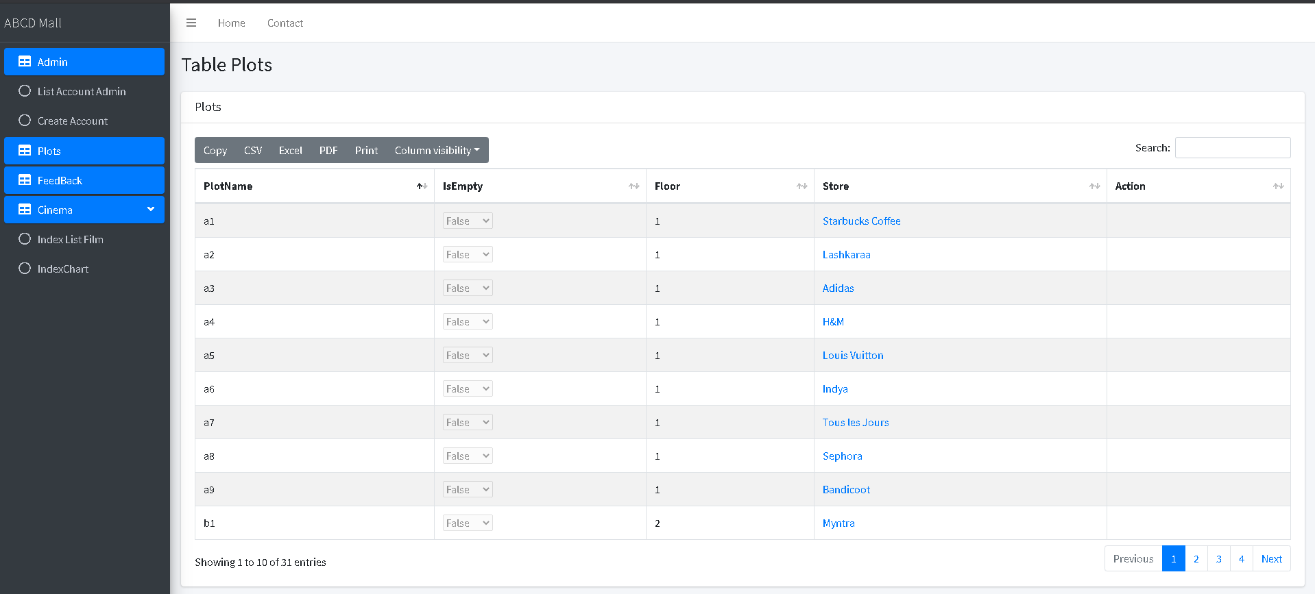

### Store details view

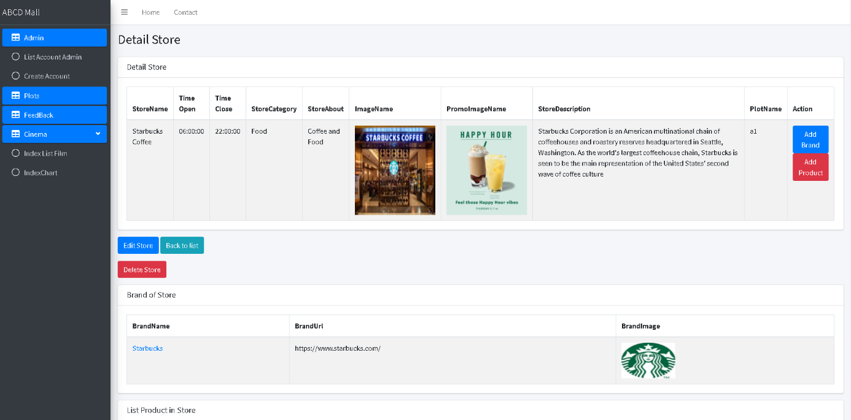

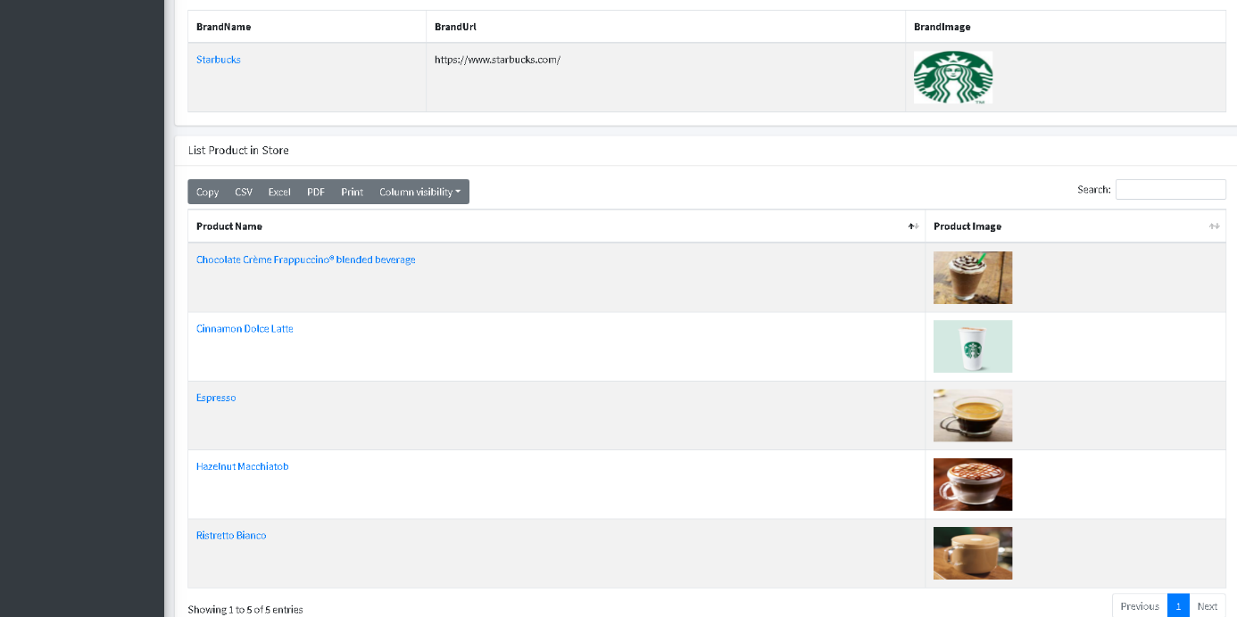

### Create Store view

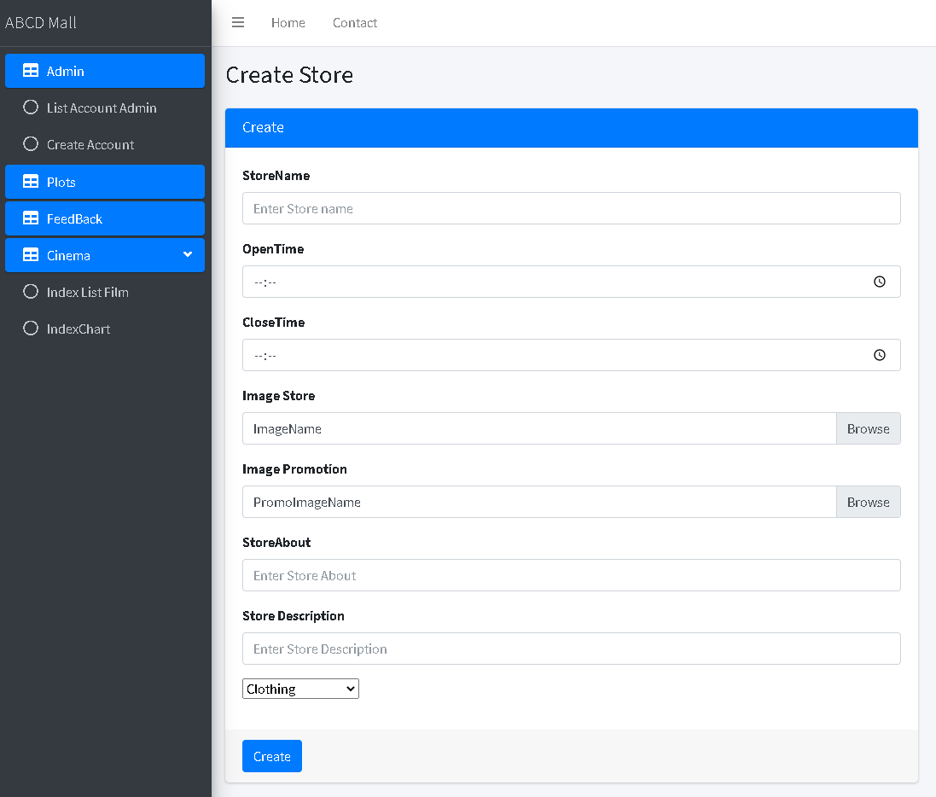

### Create product view

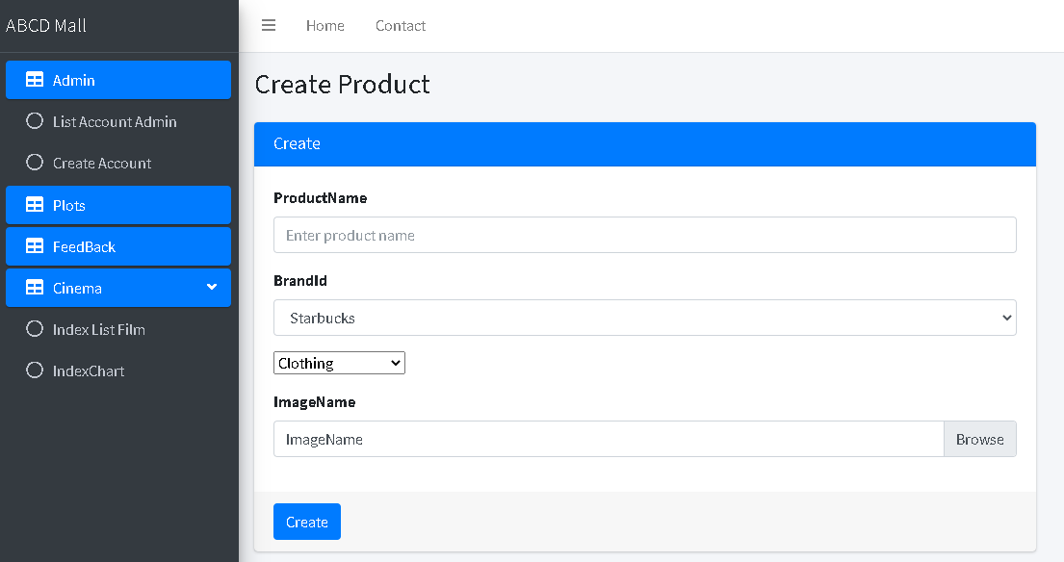

### Product details view

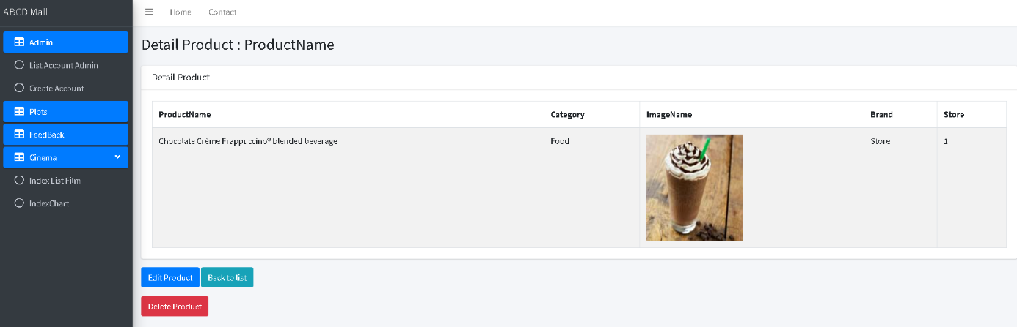

### Create brand view

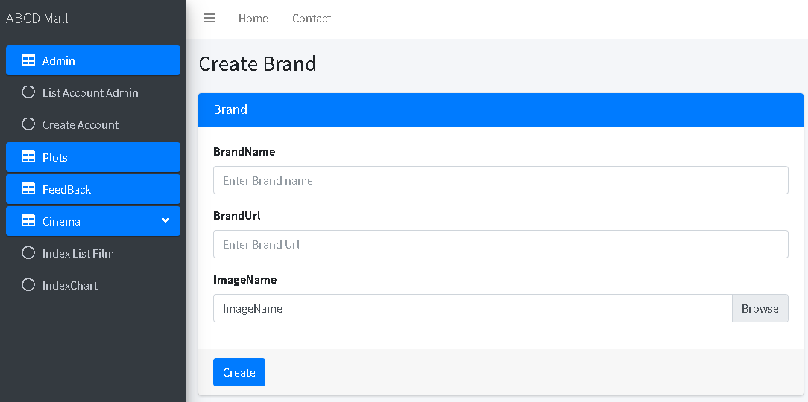

### Brand details view

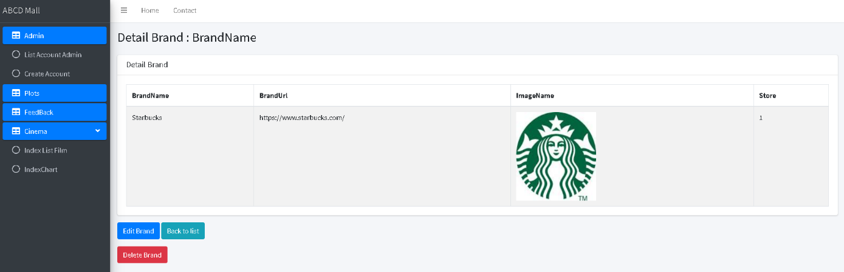

### Movie management view

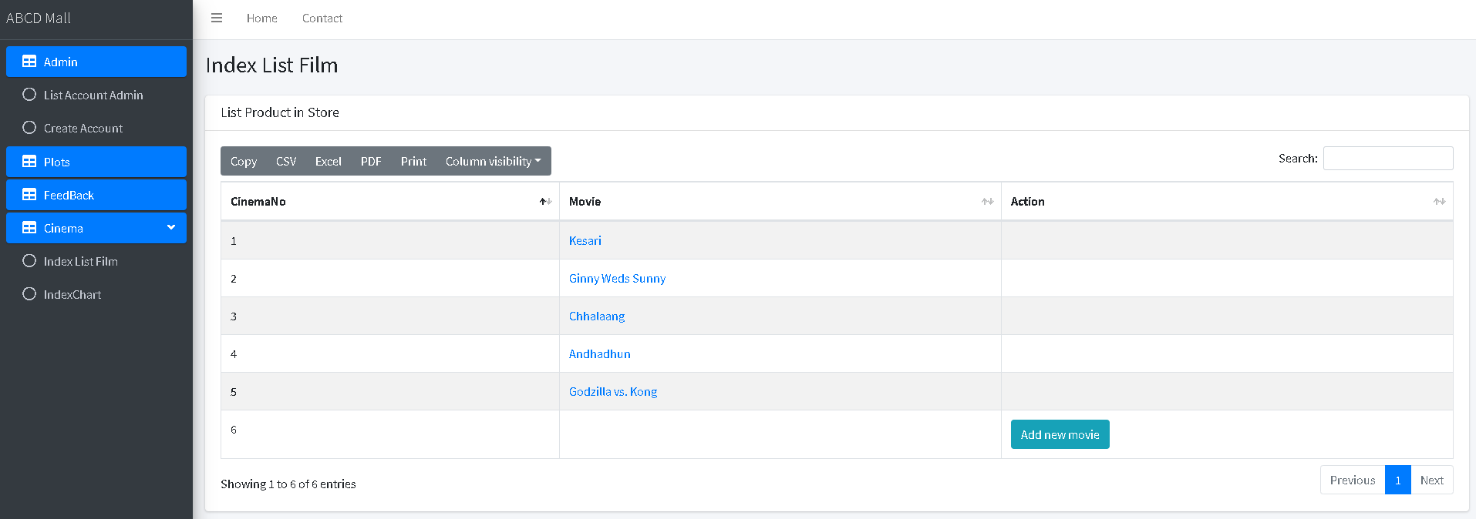

### Seat reservation management view

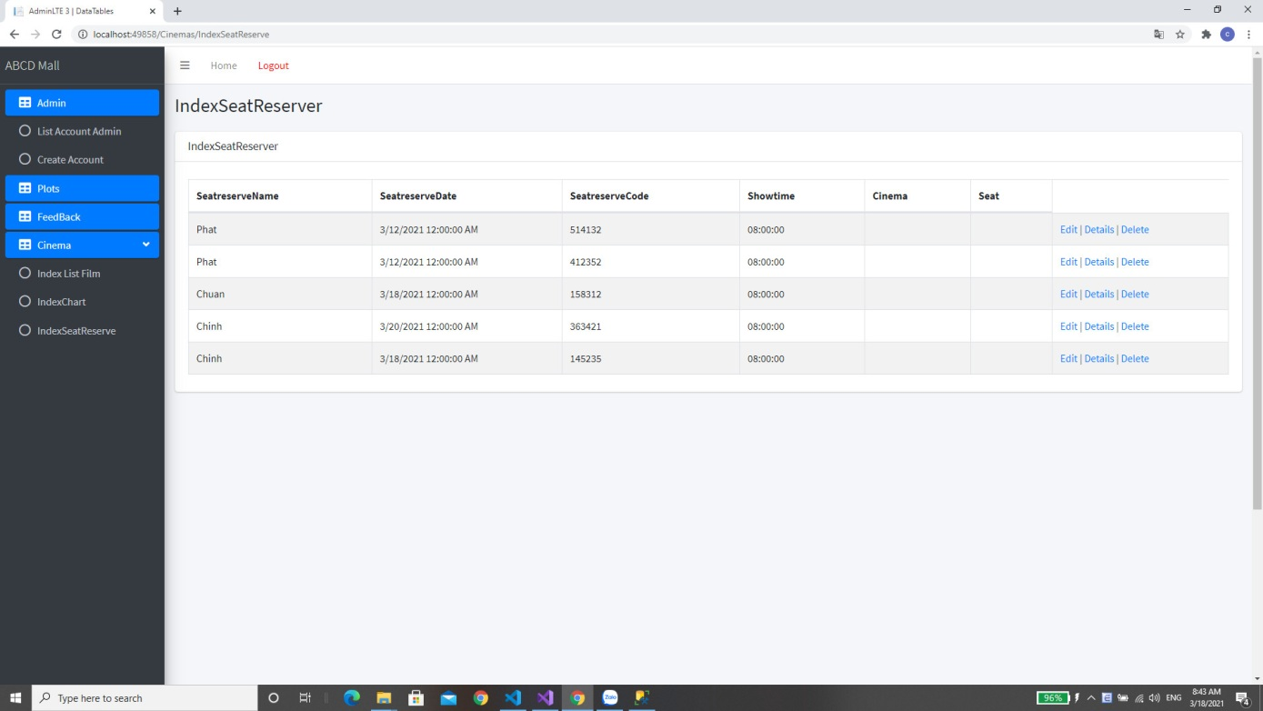

### Movie sales chart view

### Feedback management view

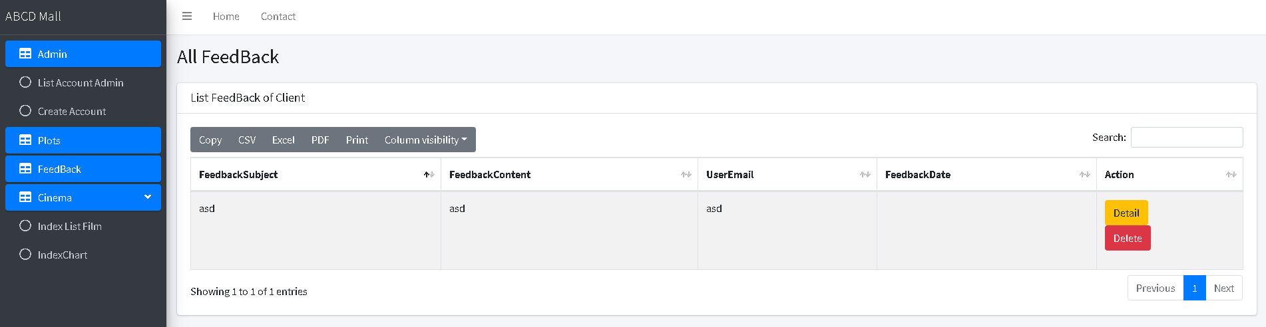

### Admin account management view

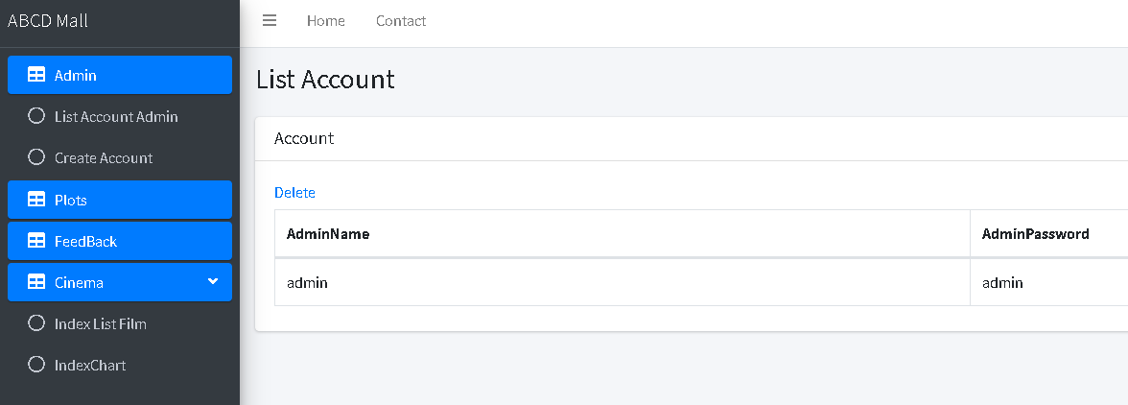

## Client Views

### Homepage

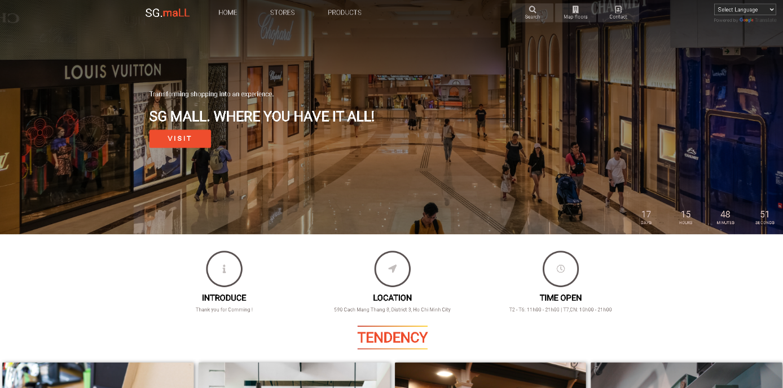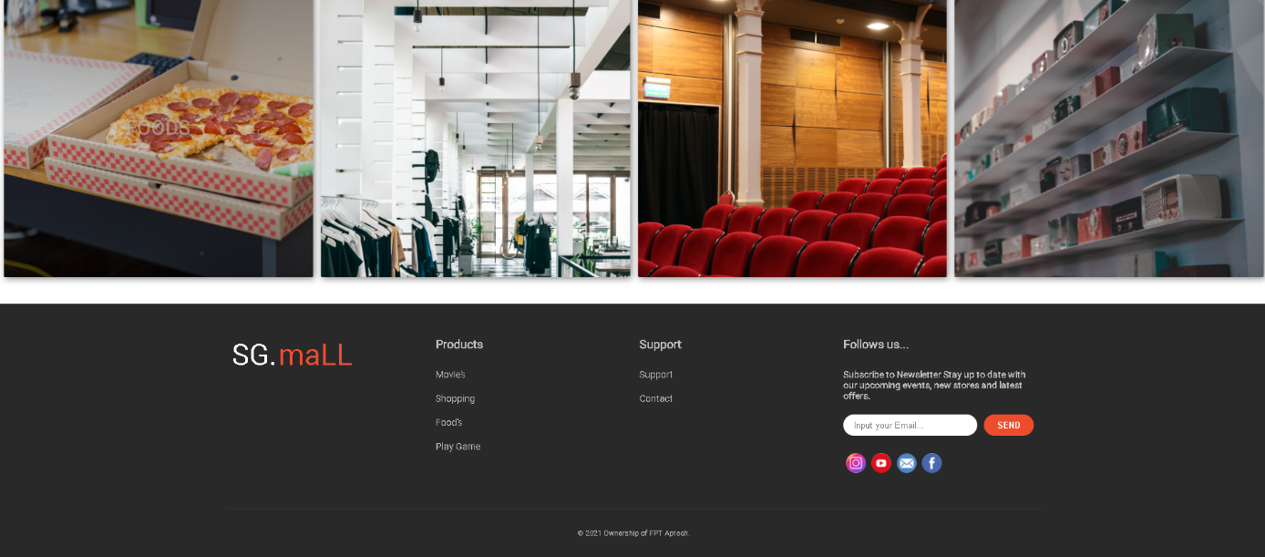

### Stores index view

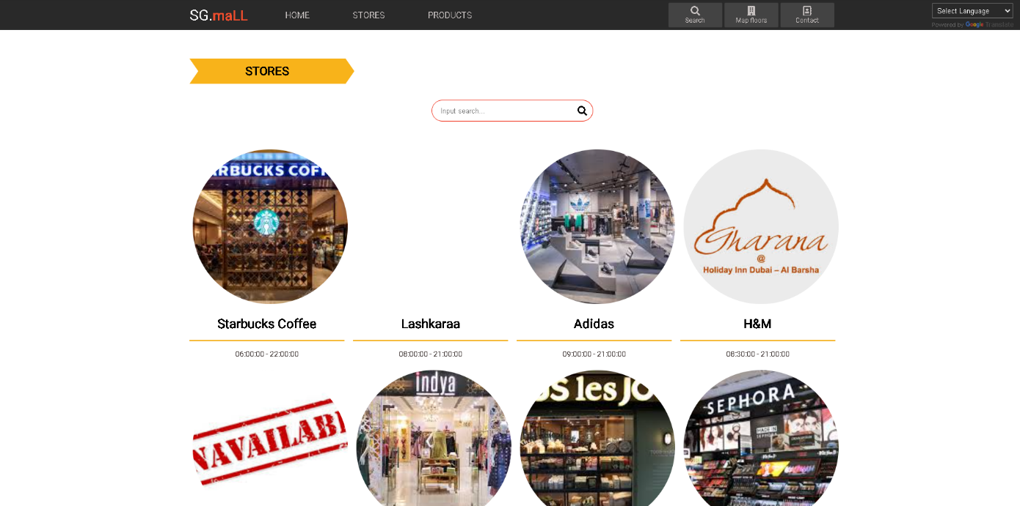

### Store details view

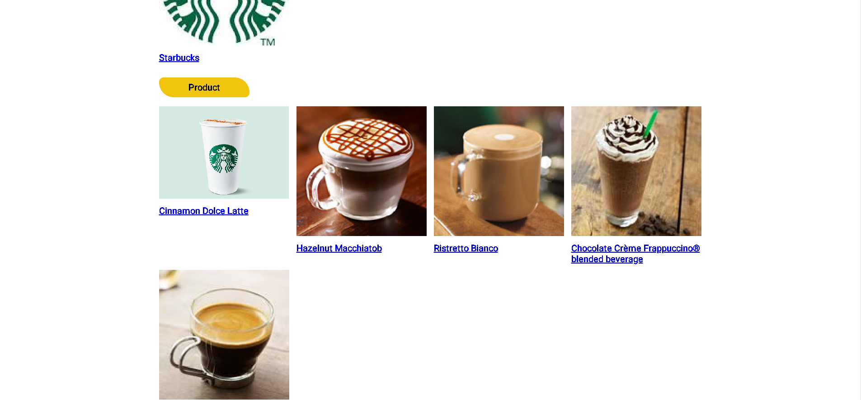

### Brands index view

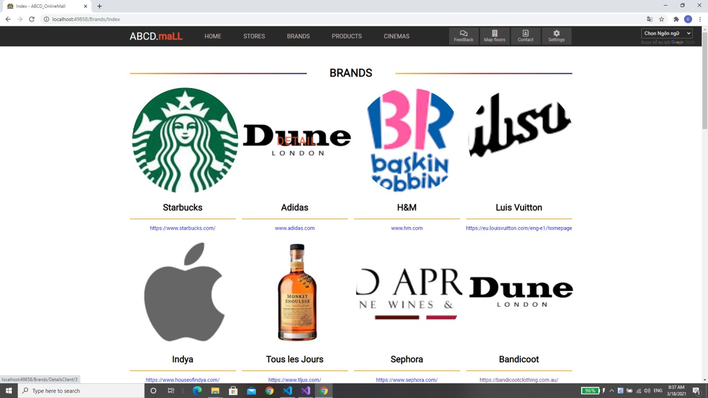

### Gallery view

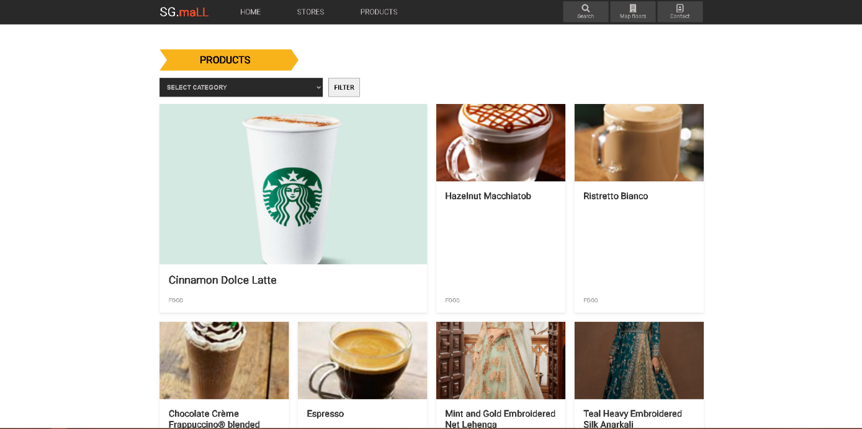

### Mall diagram view

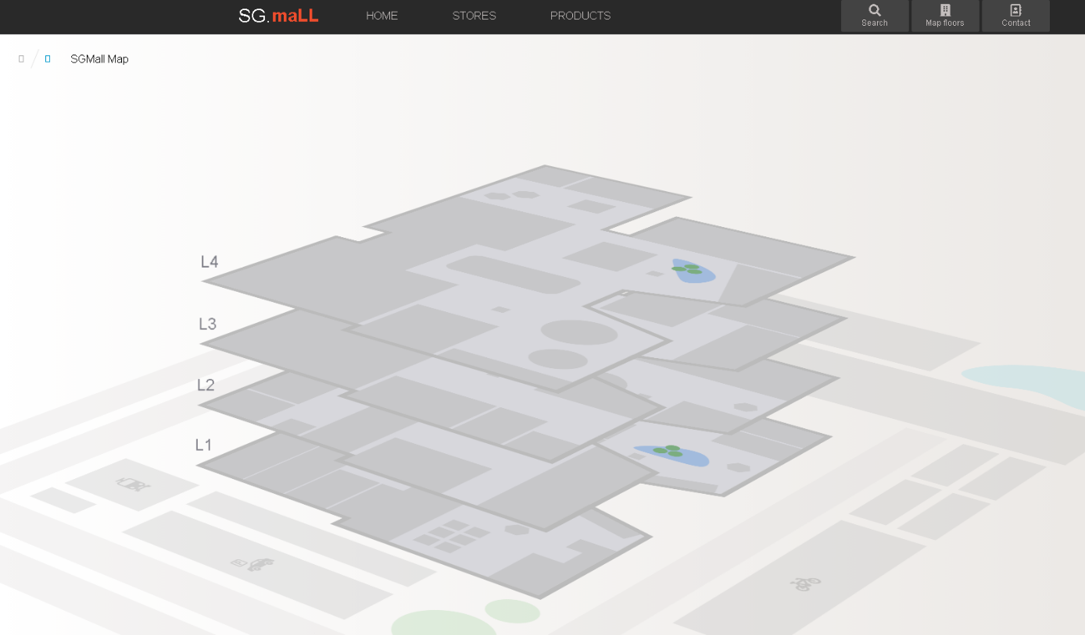

### Mall contact view

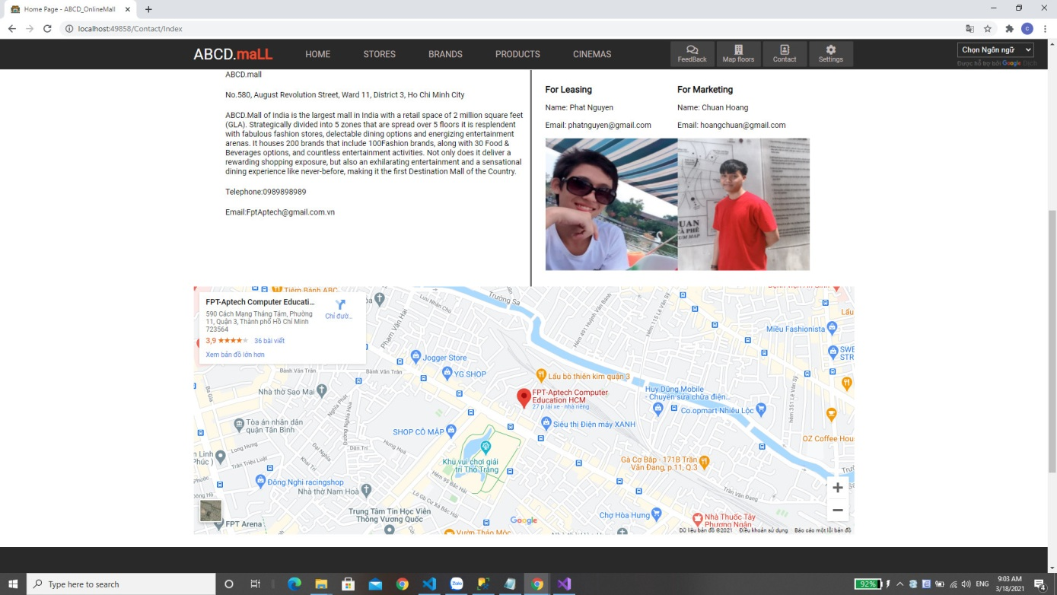

### Movies index view

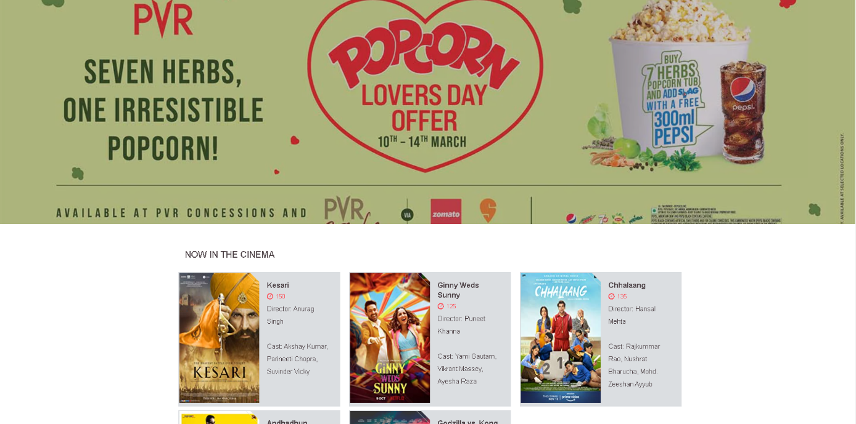

### Movie details view

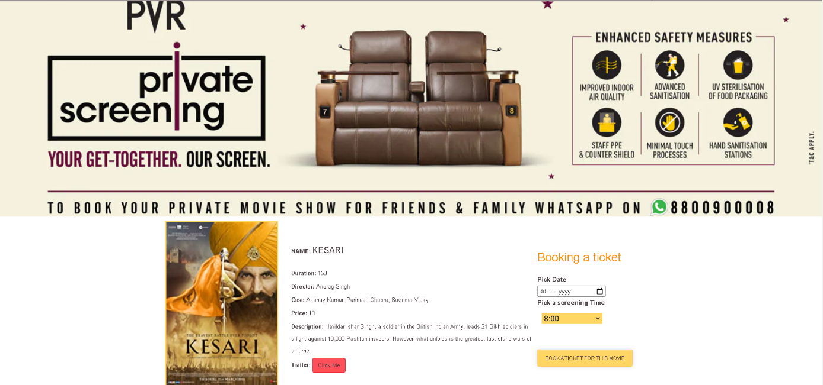

### Seat picking view

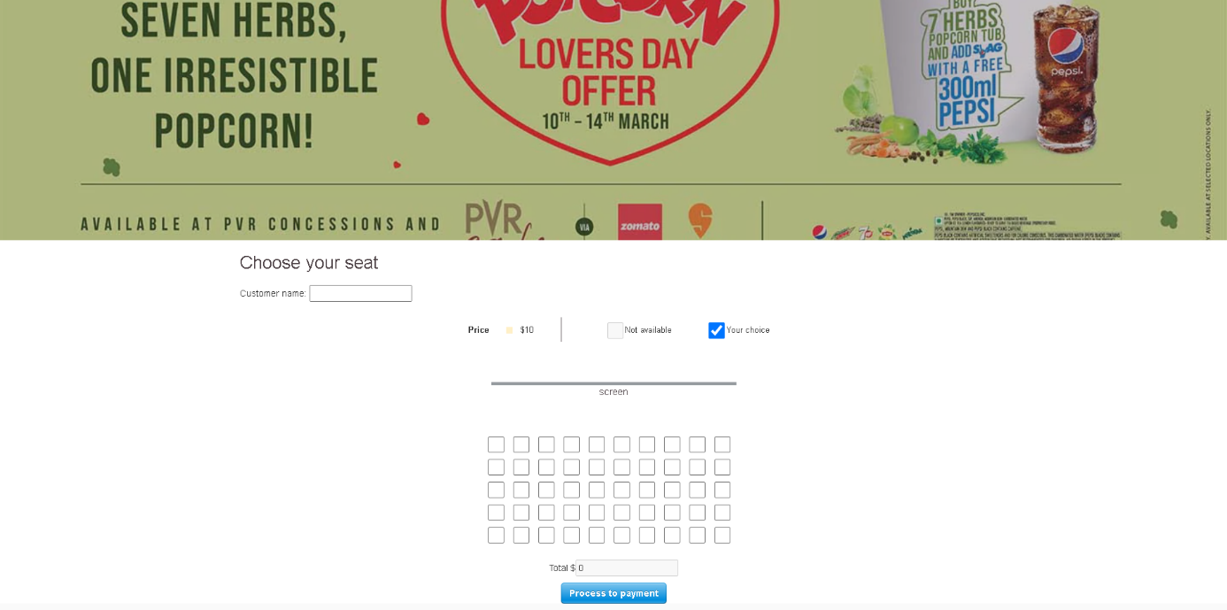

### Ticket information view

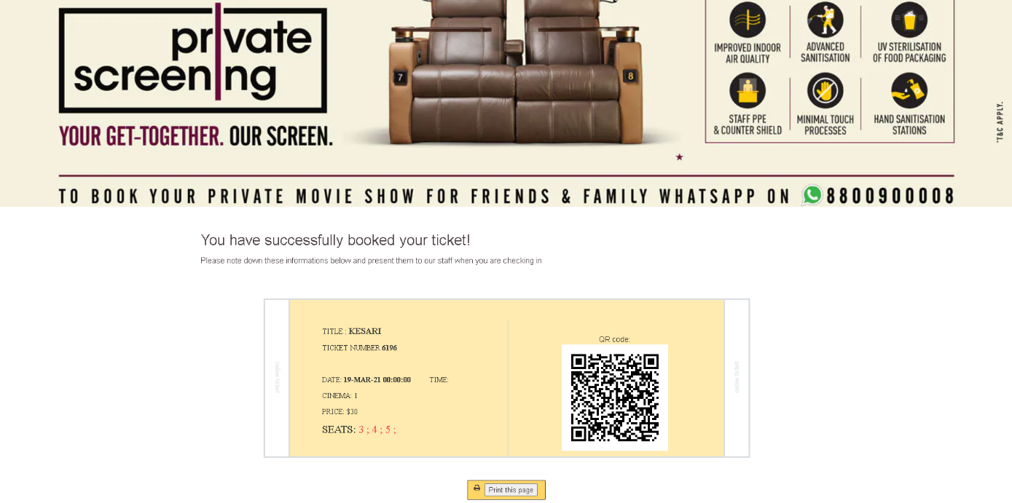

# Code integrity

## Google chart API implementation

<html>

<head>

<!--Load the AJAX API-->

<script type="text/javascript" src="https://www.gstatic.com/charts/loader.js"></script>

<script type="text/javascript">

// Load the Visualization API and the corechart package.

google.charts.load('current', {'packages':['corechart']});

// Set a callback to run when the Google Visualization API is loaded.

google.charts.setOnLoadCallback(drawChart);

// Callback that creates and populates a data table,

// instantiates the pie chart, passes in the data and

// draws it.

function drawChart() {

// Create the data table.

var data = new google.visualization.DataTable();

data.addColumn('string', 'Movie');

data.addColumn('number', 'Sales');

data.addRows([

['@ViewBag.movie1', @ViewBag.sales1],

['@ViewBag.movie2', @ViewBag.sales2],

['@ViewBag.movie3', @ViewBag.sales3],

['@ViewBag.movie4', @ViewBag.sales4],

['@ViewBag.movie5', @ViewBag.sales5],

['@ViewBag.movie6', @ViewBag.sales6]

]);

// Set chart options

var options = {'title':'Movie Sales',

'width':1400,

'height':800};

// Instantiate and draw our chart, passing in some options.

var chart = new google.visualization.ColumnChart(document.getElementById('chart_div'));

chart.draw(data, options);

}

</script>

</head>

<body>

<!--Div that will hold the pie chart-->

<div id="chart_div"></div>

</body>

</html>

## Google translate API implementation

<div id="google_translate_element"></div>

<script type="text/javascript">

function googleTranslateElementInit() {

new google.translate.TranslateElement({ pageLanguage: 'en' }, 'google_translate_element');

}

</script>

## Qrious API implementation

@{

ViewData["Title"] = "Ticket";

}

<body onload="generateQRCode()">

<script src="https://cdnjs.cloudflare.com/ajax/libs/qrious/4.0.2/qrious.min.js"></script>

<h1>You have successfully booked your ticket!</h1>

<h2>Please note down these informations below and present them to our staff when you are checking in</h2>

Time: @ViewBag.time

<br>

Cinema: @ViewBag.cinema

<br>

Date: @ViewBag.date

<br>

Name: @ViewBag.name

<br>

Total: $@ViewBag.total

<h3>Reserveation code: @ViewBag.code</h3>

<br>

Seat:

@foreach (var str in ViewBag.seat)

{

<span>

@Html.Raw(str + " ");

</span>

}

<br>

<div>

<button onclick="window.print()">Print this page</button>

</div>

<div>

<span>QR code:</span>

</div>

<canvas id="qr-code"></canvas>

<script>

document.readyState

var qr;

(function () {

qr = new QRious({

element: document.getElementById('qr-code'),

size: 200,

value: ''

});

})();

function generateQRCode() {

var qrtext = "Reserveation code: @ViewBag.code; Time: @ViewBag.time; Cinema: @ViewBag.cinema; Date: @ViewBag.date;Name: @ViewBag.name; Total: $@ViewBag.total; Seat: @foreach (var str in ViewBag.seat)

{

@Html.Raw(str+" ");

}";

qr.set({

foreground: 'black',

size: 200,

value: qrtext

});

}

</script>

</body>

## Seat picking process

**Controller**

public async Task<IActionResult> PickSeat(TimeSpan time, int cinema,DateTime date,int price)

{

var model = new viewmodel1();

model.Seat = await _context.Seats.ToListAsync();

model.Seatre2 = await _context.Seatreserves.Where(s => s.CinemaId == cinema && s.Showtime == time && s.SeatreserveDate==date).ToListAsync();

int code;

do

{

Random generator = new Random();

String r = generator.Next(0, 100000).ToString("D5");

code = int.Parse(r.ToString());

} while (_context.Seatreserves.Any(c => c.SeatreserveCode == code));

ViewBag.time = time;

ViewBag.cinema = cinema;

ViewBag.date = date;

ViewBag.price = price;

ViewBag.code = code;

return View(model);

}

**View**

****@model viewmodel1

<div class="row">

<div class="col-md-4">

<form **asp-action**="CreateReserve" **asp-controller**="Cinemas">

<div **asp-validation-summary**="ModelOnly" class="text-danger"></div>

<div class="form-group">

<label for="cinema" class="control-label">Cinema</label>@ViewBag.cinema

<input id="cinema" name="cinema" class="form-control" value="@ViewBag.cinema" hidden />

</div>

<div class="form-group">

<label for="date" class="control-label">Date</label>@ViewBag.date

<input id="date" name="date" class="form-control" value="@ViewBag.date" hidden />

</div>

<div class="form-group">

<label for="time" class="control-label">Time</label>@ViewBag.time

<input id="time" type="text" name="time" class="form-control" value="@ViewBag.time" hidden />

</div>

<div class="form-group">

<label for="price" class="control-label">Price</label>@ViewBag.price

<input id="price" name="price" class="form-control" value="@ViewBag.price" hidden />

</div>

<div class="form-group">

<label for="code" class="control-label">Code</label>@ViewBag.code

<input id="code" name="code" class="form-control" value="@ViewBag.code" hidden />

</div>

<div class="form-group">

<label for="name" class="control-label">Customer name</label>

<input id="name" name="name" class="form-control" />

</div>

@foreach (var item in Model.Seat)

{

<input name="seat" type="checkbox" id="@item.SeatNo" value="@item.SeatNo" onchange="calc()" class="seat" />

<label for="@item.SeatNo">@item.SeatNo</label>

}

@foreach (var item2 in Model.Seatre2)

{

<script>

var id = '@item2.SeatId';

document.getElementById(id).disabled = true;

</script>

}

<div class="form-group">

<span>Total</span>

$<input id="total" value="0" name="total" disabled />

</div>

<script src="https://checkout.stripe.com/checkout.js" class="stripe-button"

data-key="pk_test_51IUQtlDRkMlgUuu1vtdIW3fGVBwOZv5EncjeAHJ8sMqqvfgnqgaK449Rz0YFqqHV97LN7npLZgzsNtoR4Lsh5z6w00eeCuZaey"

data-amount=""

data-name="ABCD-Cinema"

data-description="Payment for movie tickets"

data-image="https://stripe.com/img/documentation/checkout/marketplace.png"

data-locale="en"

data-zip-code="true"

data-label="Process to payment">

</script>

</form>

</div>

</div>

<script src="https://ajax.googleapis.com/ajax/libs/jquery/3.5.1/jquery.min.js"></script>

<script>

function calc()

{

var choices = [];

var els = document.getElementsByName('seat');

for (var i = 0; i < els.length; i++) {

if (els[i].checked) {

choices.push(els[i].value);

}

}

document.getElementById('total').value = choices.length*@ViewBag.price;

}

</script>

**Task Sheet Review 3**

|  |  |  |  |  |  |
| --- | --- | --- | --- | --- | --- |
| Project Ref. No: 3 | Project Title:  Railway Reservation Manage System | Date of Preparation of Activity Plan | | | |
| No. | Task | Actual Start Date | Actual Days | Team Member Names | Status |
| 01 | Database design | 01-Mar-2021 | 18 | Nguyen Nhuan Phat | Completed |
| 02 | Mall backend | Nguyen Nhuan Phat, Hoang Giang Chuan | Completed |
| 03 | Cinema backend | Nguyen Nhuan Phat,  Vo Duc Chinh | Completed |
| 04 | Mall frontend | Hoang Giang Chuan | Completed |
| 05 | Cinema frontend | Vo Duc Chinh | Completed |
| 06 | Admin backend | Nguyen Nhuan Phat,  Dao Nguyen Xuan Huy | Completed |
| 07 | Admin frontend | Hoang Giang Chuan,  Dao Nguyen Xuan Huy | Completed |
| 08 | Google & Qrious API implementation | Nguyen Nhuan Phat | Completed |
| 09 | 3D Map implementation | Nguyen Nhuan Phat, Hoang Giang Chuan | Completed |
| 10 | Documentation and User Guide | Nguyen Nhuan Phat | Completed |

|  |  |  |
| --- | --- | --- |
|  | Prepare By: Group 3 | Approved By: Faculty |
| Date: 18-Feb-2021 | Team Leader  Nguyen Nhuan Phat | Mr. Ngo Phuoc Nguyen |